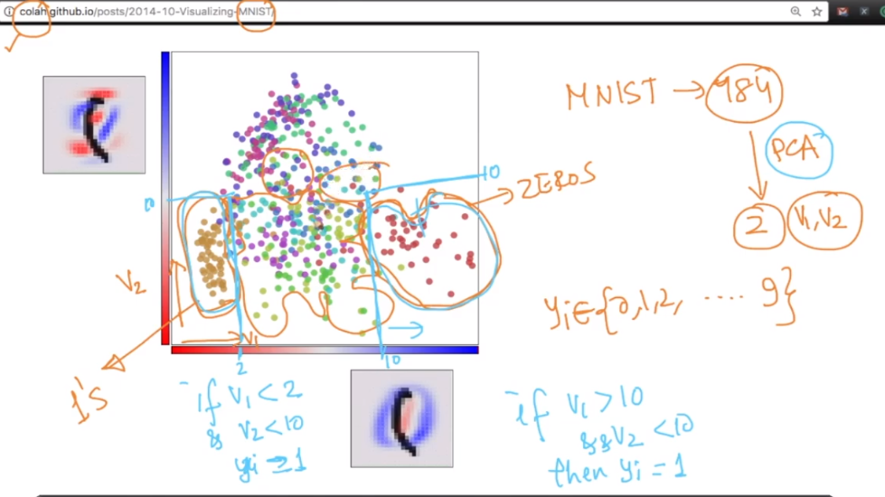

In above figure we are plotting two new components obtains from 784 components, here we can see that 1’s and zeors are clearly distinguishable and we can write if-else statement also for them, but rest of class labels are too overlapping.